Identification of Web User Behavioral Patterns for Online Time Recommendation

|  |  |  |
| --- | --- | --- |
|  | Tomas Chovanak, Ondrej Kassak, Maria Bielikova Slovak University of Technology in Bratislava Faculty of Informatics and Information Technologies Ilkovicova 2, 842 16 Bratislava, Slovakia {name.surname}@stuba.sk |  |

ABSTRACT

Understanding a website user behavior is a crucial assumption for improving the website and user experience with it. Typical and repeating features of user behavior during his visits of the website can be expressed through behavioral patterns. In this paper we represent behavioral patterns as frequent itemsets of actions frequently performed by users in their browsing sessions. Behavioral patterns have wide usage. They can be used to create recommendations, predict user’s intentions, improve website design, structure or to complex understanding of users’ behavior. We respond to actual trend of Web personalization, focusing on needs of individual users and need of data processing in an online time. In this paper we propose a novel method for behavioral patterns recognition in online time, combining global patterns with patterns specific to groups of similar users. Proposed method was evaluated indirectly through a recommendation task. We performed several experiments over data from e-learning and news domains. Our results clearly show that the combination of common global patterns and specific group patterns reaches higher recommendation precision than its components used individually. Inclusion of group patterns also brings only constant computational load, which supports its maintenance in production usage.

CCS CONCEPTS

• **Information systems** ➝ **World Wide Web** ➝ **Web mining** • **Computing methodologies** ➝ **Machine learning** ➝ **Learning paradigms** ➝ **Supervised learning**

KEYWORDS

Behavioral Patterns, Frequent Itemsets, Clustering, Data Stream; Recommendation, Data Mining

1 INTRODUCTION

Understanding behavior of website users is crucial for the site personalization and adaptation of its content and structure. Every user is unique and his actions subject to his actual aim, context etc. But when we look at behavior of multiple users together, we would be able to observe some regularities and actions typical for specific situations. These regularities are in general known as the behavioral patterns. The behavioral patterns may be modelled in various ways as frequent itemsets [4], frequent sequences of actions [3] or association rules [4]. These patterns can be applied to user groups of various sizes. For example, in e-learning domain, users can be segmented according to different learning specializations, paths or learning speed. In news domain the users can be segmented according to their common preferences for different content categories (global news, local news, entertainment, sports etc.). The best segmentation of users however may be hidden and not so clear as we outlined. Smart detecting of groups of users with similar behavior and their typical patterns may lead to better understanding of users’ intentions.

Knowledge of the behavior of web users (which may be represented by behavioral patterns) have broad utilization in different applications as outlined in [12]. It may be used for supporting website personalization, predicting users’ behavior, caching web pages or making business decisions such as market segmentation.

User actions within the website are implicit and therefore objective source of information directly describing his behavior. Mining the data from the actions results into objective information or even knowledge about users’ behavior.

Nowadays a huge amount of web usage data is generated especially within large websites with many users (i.e. big news portals, social networks). As this data come in a massive and potentially infinite stream, it has become important to be able to process them as a fast in-memory process. If we want to effectively gain knowledge about recent users’ behavior and immediately use it, it is suitable to use methods able to process the data by a single pass. Data stream algorithms are built upon models that are updated incrementally in an online time. Traditional data mining algorithms however usually require more than one pass over all data instances, which decrease their usability.

Goal of this work is to discover behavioral patterns on the level of global site community as well as on the level of specific groups of similarly behaving users. We believe that identification of communities of similarly behaving users will help to discover specific behavioral patterns, which cannot be recognized on the global level. Using knowledge about both types of behavioral patterns and even their combination will enhance their quality and usability in different applications. For this reason, we propose a novel method for identification of global and group behavioral patterns and their mutual combination specialized for recommendation of web pages for the user. At first, our method is based on the data stream clustering algorithm for segmenting active users to several groups according to their actual behavior. Next, it employs an algorithm for mining global and group behavioral patterns (represented as frequent closed itemsets) from stream of user sessions. We use identified patterns for recommending interesting pages for users to visit. Proposed method is able to detect recent behavior of global site community and also smaller communities of similar users, identify behavioral patterns for both of these community types and combine them for every user into personalized pattern sets. These could be later used for e.g., personalized recommendation or prediction of future actions.

The rest of this paper is organized as follows. In section 2, we describe existing solutions for behavioral patterns identification and discuss their characteristics. In this context we describe two research areas: frequent patterns mining and , user clustering. In section 3, we describe proposed method and its input variable tuning. In section 4, we describe evaluation of our method by the recommendation task and the methodology of performed experiments. We conclude the paper in section 5.

2 RELATED WORK

The main usage of behavioral patterns is to identify sequences of webpages, which are often visited consequently or at least in same sessions. Such an information can be used for various tasks such as website analysis, personalization, future user actions prediction, or personalized recommendation. For this reason, there were proposed multiple approaches, differing in their characteristics and thus also usage possibilities.

In [14], WebPUM method was proposed, which represents behavioral patterns as partitions resulting from a graph algorithm applied on the user navigation graph, where nodes represent web pages and edges their mutual weighted connections. The weights of edges are calculated based on intensity and frequency of page pairs being visited in same sessions. Based on the graph, the patterns are identified and pages recommended to users according their actual behavior.

Interesting method for predicting users’ future steps was proposed in [18]. It uses Fuzzy c-means clustering to find clusters of similar sessions and degree of attachment between the users and the clusters. Behavioral patterns are represented as weighted association rules mined from every cluster of user sessions.

In [22], a recommendation system is proposed by using weighted k-means clustering approach to predict the user’s navigational behavior. In offline component, the user sessions are clustered and the behavioral patterns are derived based on clusters centroids.

In [5], authors use DBscan algorithm to cluster user sessions and derive the behavioral patterns. DBScan is able to reveal otherwise ignored patterns because of their low support but high confidence when represented as association rules. Finally, the approach uses inverted index to effectively predict user behavior online.

In [19], user sessions are first clustered using k-means. Later, the Markov models are build over each cluster for behavioral patterns identification. In addition, the association rules are applied to eliminate potential ambiguity in patterns

In [23], authors use behavioral patterns represented as quantitative association rules (QARS) together with basic users’ information such as age, gender, occupation etc., to enhance recommendations for new users.

Common trait of all these approaches is that they consist of traditional offline behavioral patterns identification part which is subsequently used for online application (recommendation or prediction). A problem arises when behavior of website users arise frequently, which is typical for e.g., news portals and social networks. In these case, the patterns became quickly outdated.

2.1 Mining frequent closed itemsets over data stream

Frequent itemset can be considered as simple, but effective representation of behavioral pattern which is less complex than e.g. frequent sequences. Frequent itemsets can be further used to compute association rules, which may be considered as more complex behavioral patterns representation and may lead to new knowledge about users’ behavior. We focus on algorithms mining only frequent closed itemsets, which are complete and not redundant representations of all frequent itemsets [25].

Several algorithms were proposed for mining frequent closed itemsets task. They can be classified according to window model they use [20]. There exist several representations as landmark window containing all items from start of the stream or sliding window containing only most recent elements. Algorithms could be mining exact set of frequent itemsets or approximate set of frequent itemsets. Approximate mining is much more effective because it does not have to track all itemsets (frequent and not frequent) in history (compared to exact frequent itemset mining) and is able to well respond to conceptual drift.

First algorithm for incremental mining of closed frequent itemsets over a data stream is MOMENT [11]. It mines exact frequent itemsets using sliding window approach. It has become a baseline for solutions proposed later. It uses in-memory prefix-tree-based data structure called closed enumeration tree, which effectively stores information about infrequent itemsets, nodes that are likely to become frequent, and closed itemsets.

A successor of MOMENT algorithm called NEWMOMENT represents itemsets and window as bitsets [17]. It allows usage of efficient bitwise operations as for example to count support of itemsets or perform shift of sliding window.

CLOSTREAM uses different data structures and approach to mine exact closed frequent itemsets over sliding window than MOMENT [26] It uses Cid List and the SET function to find the closed itemsets similar to actual transaction. Unlike previous approaches it does not take so much time to search from a tree structure, because it only needs to intersect transaction with the specific closed itemsets [26].

Abandoning requirement to mine exact frequent itemsets helps to design fast algorithms for mining approximation of frequent closed itemsets like IncMine proposed in [10]. They use relaxed minimal support threshold to keep infrequent itemsets that are promising to become frequent later. They use update per batch policy that is different to all other algorithms we described here. It results in better time-per-transaction at risk of temporarily loosing accuracy of the maintained set while each batch is being collected [20]. In [20] authors use inverted index to efficiently address stored itemsets with IncMine algorithm.

Next algorithm named CLAIM for approximate frequent closed itemsets mining was proposed in [21]. This algorithm solves problem when conceptual drifts appear frequently and they slow down algorithm, by redefining frequent itemset definition and proposing usage of support value intervals considered as same value.

2.2 Clustering over data stream

A logical choice for detecting communities of similarly behaving users as a base for identifying group specific behavioral patterns is usage of user clustering. It is, as an unsupervised machine learning task, able to find the natural distribution in the data. To be able to find the behavioral process in an online time, the traditional clustering methods are however insufficient. For this reason, there is suitable to use approaches enabling stream clustering. Several algorithms were proposed in recent years.

CluStream algorithm is based on two (online and offline) components. Online microclustering component performs fast transformation of incoming data instances into compact approximate statistical representation. Offline macroclustering component uses this representation to get final results of clustering on demand [1]. This approach is adapted in other works using different macroclustering algorithms and altering microclustering phase slightly, like density based algorithm Denstream proposed in [8] that uses DBScan as macroclustering algorithm and defines new concepts of core-microclusters and outlier-microclusters. Denstream is able to detect clusters of arbitrary shapes, while it requires no assumption on the number of clusters. CluStream approach is adapted also in HPStream – projected clustering for high-dimensional data streams proposed in [2]. It outperforms basic CluStream with high-dimensional streaming data.

There are also other algorithms not based on CluStream. For example, another density based clustering algorithm D-Stream proposed in [9]. It maps input data into a density grid. Offline component clusters the grid. It adopts decaying technique to capture dynamic changes of a data stream. ClusTree [15] is parameter free algorithm that automatically adapts to the speed of the data stream with usage of compact and self-adaptive index structure for maintaining stream summaries. It incorporates the age of the objects to reflect the greater importance of more recent data.

3 METHOD FOR MINING PERSONALIZED BEHAVIORAL PATTERNS OVER A DATA STREAM

In this section, we propose a method for online mining of behavioral patterns from the user activity stream within a website. The method combines global patterns, identified from behavior of all website users, with the group patterns determined for dynamically identified groups of similar users.

*S* a user *ai* According to type of actions, it is possible to mine patterns of different complexity. For example in the case of webpage visits, there will arise high number of specific patterns describing user behavior in detail but with relatively low confidence. On the other hand, in the case of page section visits, there will arise lower number of more general patterns with high confidence.

The users are represented by their user models, containing information about their previous behavior. Based on the models, users are clustered and the behavioral patterns are identified for them. The models are updated continuously after each session, so the method for behavioral patterns identification works with up to date data and it is able to quickly react even to sudden and often changes.

Proposed behavioral patterns mining method comprises of two main steps:

1. Clustering of users into groups based on similarity of their behavior.
2. Mining global and group behavioral patterns represented as closed frequent itemsets over sessions data stream.

We implemented the method into MOA framework [7], which contains implementations of data stream frequent patterns mining algorithm IncMine and data stream clustering algorithm Clustream. We use these algorithms to first prove of concepts proposed in this paper. Later on, we plan to experiment with other algorithms and compare them with actual method results.

3.1  Similar users clustering

Important part of designed process is users clustering according to their behavior similarity in recent past. Proposed method uses CluStream algorithm consisting of fast updated microclustering phase and macroclustering phase where k-means or other traditional clustering algorithms can be applied in microclusters to find the final clusters. As our method needs to perform macroclustering regularly as part of data streaming processing, this phase should be fast enough. Therefore, we use k-means, which is fast and easy to adjust algorithm. The defined process, however, should be considered as a framework and macroclustering algorithm as well as frequent patterns mining algorithm should be matter of choice depending on usage domain requirements.

As a data stream of user sessions could be potentially infinite, we need to prevent possible memory leak caused by adding new user models to memory and not maintaining the unused ones. We represent user behavior simply as different frequency spectrums of their recent actions. The actions are stored to queue with limited capacity.

The user model *u* consists of following attributes:

* *aq*: actions queue. Queue with limited capacity to store actions the user performed in recent history.
* *gid*: group identifier. Id of group where user was classified to in the last macroclustering.
* *nsc*: new sessions count. Number of new sessions of this user since last macroclustering.
* *lmid*: last macroclustering identifier. Identifier of the last macroclustering that was performed since user’s last activity.

Macroclustering phase is performed in regular intervals (after defined number of microclusters updates). *lmid* (last macroclustering id) represents a global macroclusterings counter, which is incremented always after new macroclustering phase is performed. User *u* is assigned to a specific group (identified by *u.gid*) with his first session after new macroclustering (if his *u.lmid* < *lmid*) and his *u.lmid* is set to same value as global *lmid.* To maintain memory size at constant size, inactive users are regularly removed. For this reason, after macroclustering phase, every user model *u* with (threshold of clustering identifiers difference) is deleted.

3.2  Behavioral patterns mining

Process of behavioral patterns mining is designed to be usable in an online time. As the sessions come in a continuous stream, we process them by a single pass (Figure 1). At first, a session, represented as set of actions, is loaded from the data stream (A1 in Figure 1). As the session identification itself is an open research problem, in this paper we used a generally accepted approach dividing actions into sessions based on time gap between consecutive action (with gap 30 minutes) [13].

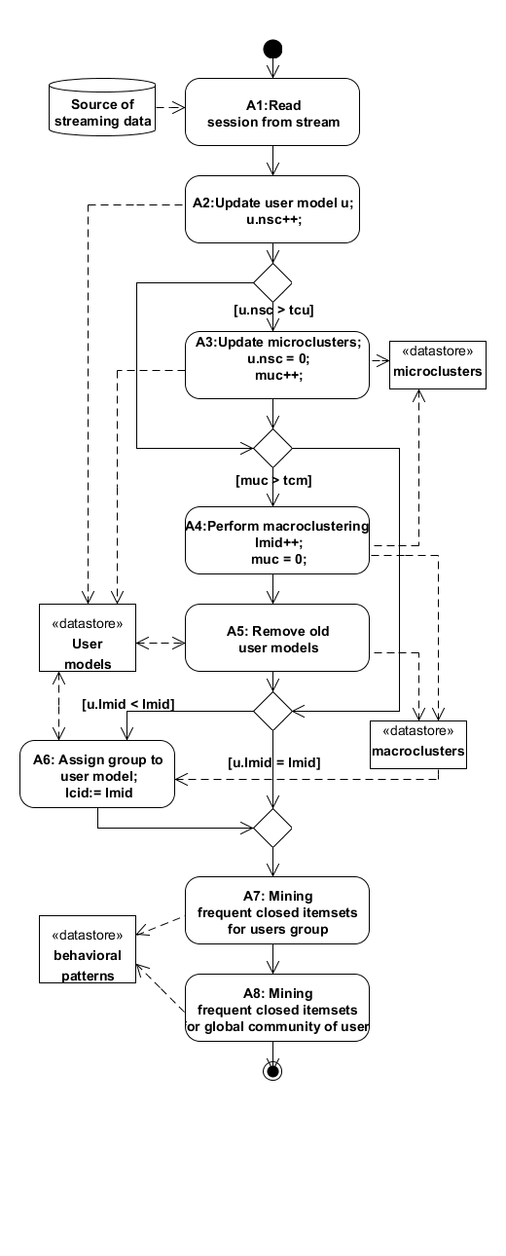

Figure 1: **Activity diagram displaying processing of user sessions within proposed method. Actions are tagged with prefix A.**

Next, the session is used for update of user model *u* (A2 in Figure 1). Actions from current session are added to the queue in the user model and *u.nsc* (new sessions count) counter is incremented. If *u.nsc* is greater than input parameter *tcu* (threshold number of changes in the user model) then *u.nsc* is set to 0 and microclusters are updated with instance generated from *u.aq* (user model’s actions queue) and *u.muc* (microclusters updates counter) is incremented by 1 (A3 in Figure 1). If number of updates in microclusters (*muc*) is greater than given threshold *tcm* (threshold number of changes in microclusters) then *muc* is set to 0 and macroclustering is performed (A4 in Figure 1).

With macroclustering, *lmid* (last macroclustering id) is incremented. And every old user model *u*, meeting condition, (where *tcdiff* parameter is threshold of clustering identifiers difference) is deleted from the memory (A5 in Figure 1). Next, if the user model *u* has *u.lmid* attribute value other than current global *lmid*, then *u.gid* is assigned an identifier of group he belongs to according to last macroclustering performed (A6 in Figure 1). Finally, user session becomes an input for algorithm mining global and group frequent patterns (A7 and A8 in Figure 1). We use *IncMine* algorithm modified to separately mine global patterns and patterns for every group as if they were separate data streams. Group patterns are mined only from sessions with assigned group identifier.

The set of found behavioral patterns $P = \{P_{1}, P_{2}, ... P_{m}\}$, where each pattern $P_{i}$ is represented as a set of actions $P_{i} = \{a_{1}, a_{2}, ..., a_{k}\}$. The global patterns …… Tle group patterns ….

After user clustering, there the behavioral patterns can be identified and selected for every user by combination of global and his group patterns. We use following strategy to choose behavioral patterns according to actual evaluation window:

1. For each $P_{i}$ in $P$ (containing global patterns and patterns from group user belongs to) approximate support value normalized to *<0,1>* interval is computed. Let’s mark it as $support(P_{i})$. Size of intersection of $P_{i}$ with $W_{e}$ is determined with *LCS* algorithm (least common subset). It is also normalized to *<0,1>* interval. Let’s mark it as $lcs(P_{i}, W_{e})$.
2. All patterns $P_{i}$ (global and group) are sorted. First by size of intersection with $W_{e}$ descending. Second by descending support value.
3. Let *M* be map of items and their *"votes"*. By iterating over all patterns votes values of items are updated. Votes value of item *i* that is contained in pattern $P_{i}$ and not in $W_{e}$ is incremented by $support(P_{i}) * lcs(P_{i}, W_{e})$.
4. Finally, *M* is sorted descending by votes values and best *r* items are selected.

3.4  Summary of parameters used

One of critical parts of designed process is to properly set up the input parameters of individual method parts (clustering algorithm, frequent patterns mining algorithm, etc.). As there exist high number of input values combinations, the method tuning could have exponential complexity. To optimize such a process, there should be used some optimizations as for example tuning individual method parts separately etc. For this reason, we divided method input parameters into four categories according their purpose (Table 1).

We use *IncMine* algorithm [20] implemented in MOA framework for mining frequent closed itemsets over data stream. We search for best settings of its input parameters: *ms*, *rr*, *sl*, *ws*. Minimal support (*ms*) is value corresponding to $σ$ parameter in *IncMine* algorithm that is used to compute progressive function of minimal support (MST) for different segments of actual window. Relaxation rate (*rr*) is value corresponding to *r* parameter in *IncMine* algorithm that is used to compute relaxed MST, which prevents it from deleting potentially frequent itemsets. Segment length (*sl*) is number of transactions (in our case these are user sessions) in one batch update. Window size (*ws*) is number of segments sliding window consists of.

We use *Clustream* algorithm using k-means macroclustering implemented in MOA framework. We search for best setting of its input parameters: number of clusters, maximal microclusters count, together with input parameters specific to our method related to clustering part: threshold number of changes in user model, threshold number of changes in microclusters (we explained their usage in process description 3.2).

Category of recommendation parameters contains: *ews*, *rc*. Evaluation window size (*ews*) represents number of actions in user session used to identify best patterns to use with recommendation. All other actions in user session following this window are used as test set to evaluate generated recommendations. Recommendation count (*rc*) represents number of actions recommended to user.

Category of general method parameters contains: *mts*, *tcdiff*. As mentioned in [16] mining of frequent itemsets over the data stream requires balancing requirements for method accuracy and effectivity according to needs of specific task it will be used in. Our method offers option to set minimal required speed as input parameter *mts*. Threshold of clustering ids difference represents maximal difference between global macroclusterings counter (*lmid*) and counter in user model u (*u.lmid*). If this threshold is exceeded user model is marked as inactive and deleted.

Table 1: **Summary of parameters**

|  |  |  |
| --- | --- | --- |
| **abbr.** | **full name** | **category** |
| *ms* | minimal support | IncMine |
| *rr* | relaxation rate | IncMine |
| *sl* | segment length | IncMine |
| *ws* | window size | IncMine |
| *gc* | groups count | clustering |
| *tcu* | max changes in user model | clustering |
| *tcm* | max changes in microclusters | clustering |
| *mmc* | maximal microclusters count | clustering |
| *ews* | evaluation window size | recommendation |
| *rc* | recommendations count | recommendation |
| *mts* | minimal transactions per second | general |
| *tcdiff* | threshold of clustering ids difference | general |

4  EVALUATION

As mentioned before, the behavioral patterns can be applied on wide scale of tasks. In this paper, we chose to evaluate the proposed method indirectly by the recommendation task. More concretely, we recommended to users interesting actions according to identified behavioral patterns similar to their actual session. We compare results of three different methods for behavioral patterns identification. First method generates recommendations using global patterns only (*GL*), second using patterns specific for groups of users with similar behavior (*GR*) while third, our proposed method, combines previous two into new hybrid method (*GG*).

Recommendation results are compared based on *precision* (Equation 2) and *speed* (Equation 3) metrics. The every user session *S* is divided into training window $A = <a_{1}, { a}_{2}, ..., a_{ews}>$ and testing window $B= <a_{ews+1}, ..., a_{|S|}>$ (actions we are comparing the recommendation to). The recommendation *R* (set of recommended actions) is generated and evaluated for every session *S* from used datasets meeting the condition $ews > 0 ⋀ ews <|S|$.

The recommendation *precision* is then computed as:

|  |  |
| --- | --- |
|  | (2) |

Another important metric expressing the usability of recommendation is the *speed*. It is defined as average number of sessions processed in a second:

|  |  |
| --- | --- |
| $$speed = \frac{number of processed sessions }{processing time [s]}$$ | (3) |

4.1  Datasets

We evaluated proposed method on two datasets from domains with different characteristics. First used dataset come from e-learning system (ALEF) [6], second dataset belongs to news portal (NP). Preprocessing of both datasets consisted mainly of users’ sessions identification and omitting of too short sessions (1 action long). As our method process data in the single pass, we evaluated it by test-then-train [7] approach, where each single observation is used to test the model before it is used for training. This way method is evaluated on the whole datasets.

ALEF dataset contains 24k user sessions from 870 users. The actions were performed between 26/10/2010 and 30/04/2013 (917 days but only 737 active). There is in average 33.37 sessions per active day with 15 actions in average per session. In this e-learning system, users could visit 2072 different learning objects (web pages).

In NP dataset there exist 334k sessions. Data was collected between 01/03/2015 and 01/07/2015 (122 active days). In average there exist 2739.8 sessions per day with 3 actions in average per session, which is significant difference from ALEF dataset. For simplicity of evaluation we removed all user sessions with length less than 3 as these sessions bring noise and lower the quality of mined. In NP there is 199k users. Many of them are much less active than users in ALEF and they do not return to the site so often if even. In news portal there exist several thousands of pages (articles) and they are active for too short time to be able to recognize behavioral patterns over their visits. For this reason, we abstract the pages into 85 categories (e.g., culture, sport) and recognized patterns over them. This abstraction brings significant patterns recognition method speed (lower number of possible actions and patterns) and patterns quality (higher patterns occurrence) increase in comparison to ALEF dataset.

4.2  Searching for the best configurations

Considering number of input parameters our method takes (described in section 3.4), we used grid search approach to find most promising configurations maximizing recommendation precision. To reduce space of possible parameter values combinations, we tuned method parts independently based on their category (Table 1). In this section we describe best found configurations of individual categories of parameters.

Results from ALEF dataset are affected by minimal speed requirements (*mts*), which we set to 15 transactions per second. Patterns for ALEF are discovered in high dimensional space of all possible pages, which slows down the processing. For this reason, multiple parameter configurations met the minimal speed requirements and have to be skipped. In NP dataset, processing is much faster due to lower dimensionality of actions (page categories) and therefore *mts* value we set doesn’t affect the results quality. In Table 2 there are enumerated all parameters’ values we searched for.

Let h be number of recent sessions stored in memory. It is computed as: $h = ws * sl$. Evaluation of every parameter configuration starts after certain number of transactions are processed. It is computed as: $h_{m}=\max_{c ∈C}{h_{c}}$. Where C is set of all searched configurations of parameters. This approach is used for the reason that the configuration with smaller h is able to recommend sooner than configurations with higher h value. For first category (IncMine algorithm) we evaluated 270 different parameter configurations. In both domains we observed that configurations with longer window size (ws = 15) and shorter segment length (sl = 25) reach higher precision.

Next, we observed that too small value of *ms* causes generation of too many patterns, which causes slowing down the method and failing in minimal method speed requirement in ALEF domain. On the other hand, too high *ms* value causes generating of small number of patterns only, which could cause missing of some potentially important patterns.

Table 2: **Parameters values used as search space in grid search.**

|  |  |
| --- | --- |
| **abbr.** | **Values** |
| *ms* | 0.005, 0.01, 0.02, 0.03, 0.04, 0.05, 0.1 |
| *rr* | 0.1, 0.5, 0.9 |
| *sl* | 25, 50, 100, 150, 200, 500 |
| *ws* | 5,10,15 |
| *gc* | 2, 4, 6, 8 |
| *tcu* | 5,10,15 |
| *tcm* | 50, 100, 200, 400, 800 |
| *mmc* | 100,1000 |
| *ews* | 1,2,3,4,5,6,7, 8, 9, 10 |
| *rc* | 1,2,3,4,5,10,15 |
| *mts* | 15 |
| *tcdiff* | 1,2,3,4, 5,6,7,8,9,10 |

Tuning the parameters from second category used for clustering brought 120 different configurations. We observed that clustering users to small number of groups (<4) was less successful, because some groups were incorrectly joined together. In both domains, we observed best results when using smaller value of *tuc* (threshold of user model updates) in combination with higher *tcm* (threshold of microclusters updates). It means that microclusters are updated more often for recent users’ behavior and also number of microclusters updates required, to perform macroclustering, is reasonably higher to capture enough information to be able to cluster users correctly. For the third category of parameters (recommendation), we tuned only a parameter *ews* (evaluation window size). Different values of other parameters from this category (*rc*) were evaluated implicitly for every configuration to be able to compare all results for different number of recommended items. Let $l_{s}$ be length of session *s*. For recommendation evaluation we could only use sessions with $l_{s} >= ews + rc$. That’s why tuning of *ews* and *rc* changes the number of sessions usable for the evaluation. We cannot directly compare parameter configurations with different values of *ews* and *rc* (it would be only possible if we omit great number of short sessions). We observed that for ALEF dataset, the best results were accomplished for *ews* > 2 and *ews* < 6. For NP with many short sessions, *ews=1* performed the best results for recommendation of less than 4 items. Recommendation of multiple items, however, reached better results with higher *ews* value.

For last category of parameters (general), we observed that deleting inactive user models too soon (when *tcdiff* is low), after new macroclustering is performed, cause worse results. In both domains, we observed trend of precision increase after increasing the *tcdiff* threshold. In ALEF dataset ascending precision trend was visible until *tcdiff = 5.* Student behavior in ALEF is highly bound to actual course studied. For this reason, their user model should be removed after finishing the course. In news domain, an ascending trend in precision (with ascending *tcdiff*) was visible for all evaluated *tcdiff* values (1-10). In news domain we represent user actions as category visits, which are stable and thus usable for longer time periods. In this case, the models should remain until users are active in the website.

4.3 Best configuration search results

Finally, according to performed search, for each dataset, we chose the best configuration maximizing precision metric and processing speed (Table 3). For these best settings, we compared proposed method to the baseline methods using global and group only patterns (Table 4).

Table 3: **Best configurations of parameters for both domains.**

|  |  |  |  |  |  |  |  |  |  |
| --- | --- | --- | --- | --- | --- | --- | --- | --- | --- |
| **ms** | **ews** | **rr** | **sl** | **Ws** | **gc** | **tcu** | **tcm** | **mmc** | **tcdiff** |
| ***ALEF*** | | | | | | | | | |
| **0.05** | **2** | **0.1** | **25** | **15** | **6** | **5** | **400** | **100** | **5** |
| ***NEWSPAPERS PORTAL*** | | | | | | | | | |
| **0.05** | **1** | **0.5** | **25** | **15** | **8** | **5** | **800** | **1000** | **15** |

Table 4: **Differences in precision of methods for best configuration in ALEF and NP. GG marks recommendation method using global and group patterns combination. GL marks method using global patterns only. GR marks method using only group patterns.**

|  |  |  |  |  |  |  |
| --- | --- | --- | --- | --- | --- | --- |
|  | **P@1** | **P@2** | **P@3** | **P@4** | **P@5** | **P@10** |
| **ALEF** | | | | | | |
| ***GG*** | **50.91%** | **50.97%** | **50.78%** | **50.70%** | **50.86%** | **50.38%** |
| ***GL*** | **48.94%** | **49.16%** | **49.12%** | **49.07%** | **49.04%** | **48.42%** |
| ***GR*** | **38.07%** | **37.98%** | **37.82%** | **37.67%** | **37.79%** | **37.13%** |
| ***GG – GL*** | **1.97%** | **1.81%** | **1.66%** | **1.63%** | **1.82%** | **1.96%** |
| ***GG -GR*** | **12.84%** | **12.99%** | **12.96%** | **13.02%** | **13.07%** | **13.25%** |
| **NEWSPAPERS PORTAL** | | | | | | |
| ***GG*** | **65.08%** | **53.90%** | **55.79%** | **55.73%** | **54.79%** | **51.15%** |
| ***GL*** | **63.86%** | **52.81%** | **54.66%** | **54.23%** | **52.76%** | **48.89%** |
| ***GR*** | **13.35%** | **11.09%** | **15.78%** | **20.35%** | **23.65%** | **12.18%** |
| ***GG - GL*** | **1.21%** | **1.09%** | **1.13%** | **1.50%** | **2.21%** | **2.26.%** |
| ***GG – GR*** | **50.51%** | **41.71%** | **38.88%** | **30.82%** | **31.58%** | **50.34%** |

We performed statistical t-test to compare precisions of baseline methods. For ALEF dataset our method reached significant increase of precision when compared to method using only global patterns (p < 0.0001, t= 9.7153, df= 7600, difference of means 0.0165) and also compared to method using only group patterns (p < 0.0001, t=103.2904, df=7600, difference of means 0.2143). For NP dataset we reached also significant increase compared to method using only global patterns (p < 0.0001, t=3.8976, df=12598, difference of means 0.0086) and also compared to method using only group patterns (p < 0.0001, t=239.6845, df=12598, difference of means 0.4137).

4.4 Evaluating relations between group and global patterns

For each user session, we evaluate separately results of recommendation approach that is using global behavioral patterns only (*GL*), group behavioral patterns only (*GR*) and using their combination (*GG*). This results in three different sets of successful recommendations (Figure 2).

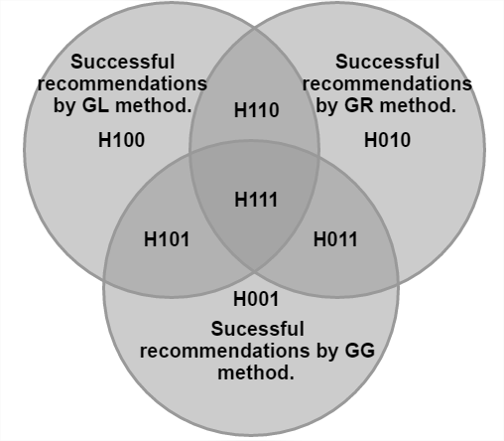

Figure 2: Venn diagram displaying sets of successful recommendations gained by different methods and marking of their intersections. Each part of the diagram is marked as H (hits) following by three bits. First bit marks set of successful recommendations gained with *GL*, second with *GR* and third with *GG*.

To be able to compare results of combined *GG* method not only to its parts (*GL*, *GR*), we present also the best theoretical combination of both individual methods (Table 5). In this case, the better result of *GL* and *GR* is chosen for every session. Based on this information, it is possible to evaluate the quality of used approaches combination.

From the experiment results, we observe quite large intersection of successful recommendations generated based on global and group patterns (*H110+H111*). Number of successful recommendations generated by usage of global patterns only (*H100+H101*) is much higher than number of successful recommendations generated with usage of group patterns only (*H010+H011*). The reason is that small number of sessions within groups results into low quality patterns (low support). We observed that precision is higher in larger groups with many active users (several hundreds).

In addition to overall precision, we observed recommendation precision inside each user group during the stream processing. The results were logged in regular intervals before new macroclustering (in total, 9 measurements were realised during stream processing in ALEF and 18 measurements in NP) (Figure 3).

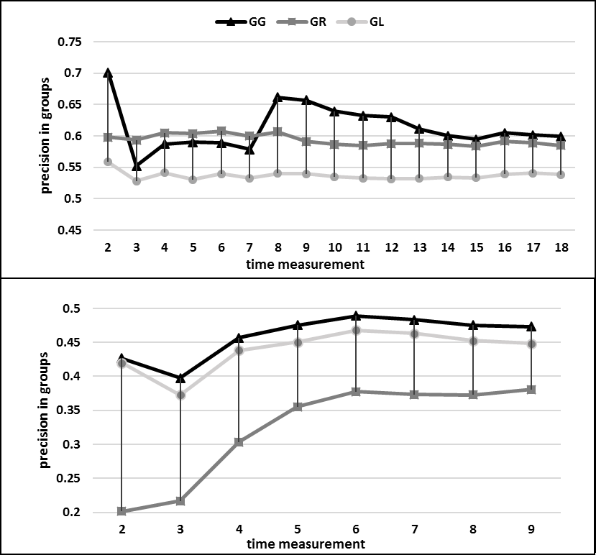

Figure 3: Average recommendation precision within groups for NP (upper) and ALEF datasets (lower). Precision is computed as average of precisions inside each group. *GG* marks method using global and group patterns combination. *GL* marks method using only global patterns. *GR* means method using only group patterns.

From these results is visible that *GG* for both datasets reached the highest precision, which shows that it is suitable to combine global and group patterns. The difference, however, lies in results of *GL* and *GR*. In ALEF dataset, *GL* reached better precision in comparison to *GR*, while in the case of NP dataset, the situation is opposite. It is caused by the number of users in the datasets. In NP, there exist high amount of users, so they can be clustered into highly similar and quality groups. For this reason and despite the short sessions, there can be identified quality patterns. In ALEF, there are less users, who in addition perform more specific sessions and thus it is unable to create such quality behavioral patterns. Despite this restriction, group patterns are useful, as can be seen from results of *GG*, which outperformed the *GL* method. Results of both methods are able to find unique patterns.

4.5 Evaluating speed

For approaches specialized in data stream processing, computation time represent one of the crucial criterions of usability. For this reason, we observed, in addition to recommendation precision, also the processing speed of proposed method logged in

Table 5: Facts computed from sets of successful recommendations from different methods.

|  |  |  |  |  |  |  |  |  |  |  |  |
| --- | --- | --- | --- | --- | --- | --- | --- | --- | --- | --- | --- |
| **Description of** | **Computed as** | **ALEF** | | | | | **NEWSPAPERS PORTAL** | | | | |
| **P@1** | **P@2** | **P@3** | **P@4** | **P@5** | **P@1** | **P@2** | **P@3** | **P@4** | **P@5** |
| Hypothetic situation, where more precise result is always chosen (from *GL* and *GR*) | H111+H110+H101+H100+H011+H010 | **55.14** | **57.02** | **58.40** | **59.06** | **59.88** | **66.79** | **55.92** | **59.33** | **60.65** | **61.00** |
| *GG* | H101+H011+H001+H111 | **50.71** | **51.26** | **51.73** | **51.96** | **52.41** | **64.88** | **53.68** | **55.68** | **55.66** | **54.91** |
| *GL* | H111+H110+H101+H100 | **49.27** | **49.85** | **50.44** | **50.73** | **51.06** | **63.69** | **52.62** | **54.58** | **54.19** | **52.76** |
| GR | H111+H011+H110+H010 | **32.41** | **32.93** | **33.21** | **33.24** | **33.57** | **13.06** | **10.86** | **15.43** | **19.88** | **23.07** |
| Recommendations generated uniquely of group patterns and not global patterns. | H011 + H010 | **5.86** | **7.17** | **7.97** | **8.33** | **8.82** | **3.10** | **3.30** | **4.74** | **6.46** | **8.24** |
| Recommendations generated uniquely of global patterns and not group patterns. | H101+H100 | **22.72** | **24.09** | **25.19** | **25.82** | **26.31** | **53.72** | **45.06** | **43.90** | **40.78** | **37.93** |
| Recommendations generated uniquely by combination of global and group patterns. | H001 | **0.32** | **0.84** | **1.19** | **1.54** | **1.84** | **0.08** | **0.49** | **0.80** | **1.24** | **1.70** |

regular time intervals. To be able to consider computational cost of user clustering, group patterns creation and their combination with global patterns, we compared it to result of GL method computing global patterns only (Figure 4).

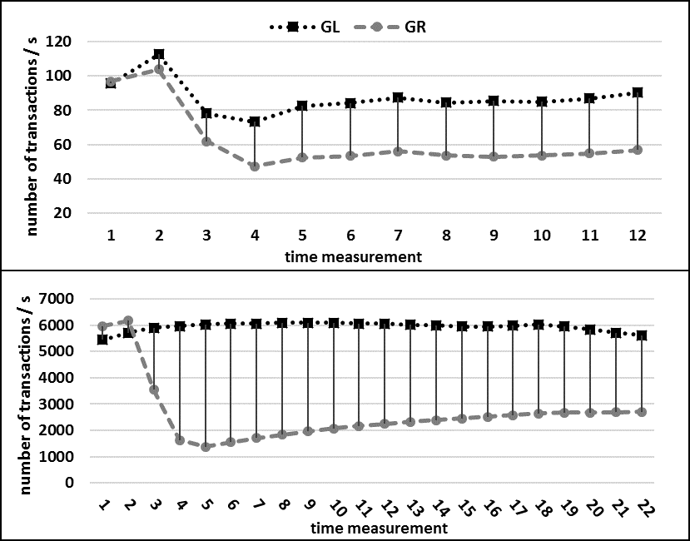

Figure 4: Average processing speed of ALEF (upper) and NP datasets (lower). The measurements are taken every 2000 transactions.

From the results is visible that additional cost caused by clustering and searching for group patterns is constant and thus maintainable in production. Another finding came from comparison of results between both domains. We can see that computation is faster in order in the case of NP dataset. The reason is the number of possible items, from which are identified the behavioral patterns (tens of categories in NP, hundreds of pages in ALEF). This in addition shows up, how items abstraction helps to significantly reduce computation time.

5 CONCLUSIONS

Many existing methods for behavior patterns mining consist of computationally expensive offline part, which limits their usage in dynamically changing web sites. In this paper, we propose a method, able to perform pattern mining and its application in an online time by usage of data streams processing algorithms. The method identifies the behavioral patterns by combining frequents itemsets of actions performed by whole website user community with the itemsets of actions performed by groups of similar users. This way, it is possible to find, for individual users, more specific patterns than is typically offered by existing approaches.

The proposed method was evaluated on data from e-learning and news domains, which have highly different characteristics (total size, number of users, different average length of session, etc.). We performed multiple experiments mainly with purpose to investigate how useful is the combination of global and group patterns. The method was evaluated indirectly through recommendation task, where we observed precision and speed (which is important because of data stream processing) of patterns identification. Results clearly show that usage of group and global patterns together significantly enhances recommendation precision, in comparison to usage of global patterns only, in both domains.

We showed that additional computational cost of method using combination of global and group patterns, , is constant in comparison to method using global patterns only and thus it is maintainable in production usage. Next, wee plan to evaluate proposed method by using multiple different algorithms for mining frequent itemsets (top-k frequent itemsets mining algorithm without minimum support input [24]) and clustering (D-Stream and Clustree) and compare the results. We will also try to parallelize individual tasks of the method, which can help to make method even faster. Input data stream could be copied to 3 separate branches – user clustering, mining of group behavioral patterns and mining of global behavioral patterns.

REFERENCES

|  |  |
| --- | --- |
| [1] | Aggarwal, Charu C., et al. "A framework for clustering evolving data streams." Proceedings of the 29th international conference on Very large data bases-Volume 29. VLDB Endowment, 2003 |
| [2] | Aggarwal, Charu C., et al. "A framework for projected clustering of high dimensional data streams." Proceedings of the Thirtieth international conference on Very large data bases-Volume 30. VLDB Endowment, 2004 |
| [3] | Agrawal, Rakesh, and Ramakrishnan Srikant. "Mining sequential patterns." Data Engineering, 1995. Proceedings of the Eleventh International Conference on. IEEE, 1995 |
| [4] | Agrawal, Rakesh, Tomasz Imieliński, and Arun Swami. "Mining association rules between sets of items in large databases." Acm sigmod record. Vol. 22. No. 2. ACM, 1993 |
| [5] | Anandhi, D., and MS Irfan Ahmed. "An Improved Web Log Mining and Online Navigational Pattern Prediction." Research Journal of Applied Sciences, Engineering and Technology 8.12 (2014): 1472-1479 |
| [6] | Bieliková, Mária, et al. "ALEF: from application to platform for adaptive collaborative learning." Recommender Systems for Technology Enhanced Learning. Springer New York, 2014. 195-225 |
| [7] | Bifet, Albert, et al. "Moa: Massive online analysis." Journal of Machine Learning Research 11.May (2010): 1601-1604 |
| [8] | Cao, Feng, et al. "Density-based clustering over an evolving data stream with noise." Proceedings of the 2006 SIAM international conference on data mining. Society for Industrial and Applied Mathematics, 2006 |
| [9] | Chen, Yixin, and Li Tu. "Density-based clustering for real-time stream data." Proceedings of the 13th ACM SIGKDD international conference on Knowledge discovery and data mining. ACM, 2007 |
| [10] | Cheng, James, Yiping Ke, and Wilfred Ng. "Maintaining frequent closed itemsets over a sliding window." Journal of Intelligent Information Systems 31.3 (2008): 191-215 |
| [11] | Chi, Yun, et al. "Moment: Maintaining closed frequent itemsets over a stream sliding window." Data Mining, 2004. ICDM'04. Fourth IEEE International Conference on. IEEE, 2004 |
| [12] | Facca, Federico Michele, and Pier Luca Lanzi. "Recent developments in web usage mining research." International Conference on Data Warehousing and Knowledge Discovery. Springer Berlin Heidelberg, 2003 |
| [13] | Herder, Eelco. An Analysis of User Behavior on the Web-Understanding the Web and its Users. VDM Verlag, 2007. |
| [14] | Jalali, M., Mustapha, N., Nasir Sulaiman, M. and Mamat, A.2010. WebPUM: A Web-based recommendation system to predict user future movements Expert Systems With Applications, 37, 6201–6212. DOI: http://dx.doi.org/10.1016/j.eswa.2010.02.105 |
| [15] | Kranen, Philipp, et al. "The ClusTree: indexing micro-clusters for anytime stream mining." Knowledge and information systems 29.2 (2011): 249-272 |
| [16] | Lee, Victor E., Ruoming Jin, and Gagan Agrawal. "Frequent pattern mining in data streams." Frequent Pattern Mining. Springer International Publishing, 2014. 199-224 |
| [17] | Li, Hua-Fu, et al. "A new algorithm for maintaining closed frequent itemsets in data streams by incremental updates." Sixth IEEE International Conference on Data Mining-Workshops (ICDMW'06). IEEE, 2006 |
| [18] | Liraki Z. and Harounabadi A. 2015. Predicting the Users’ Navigation Patterns in Web, using Weighted Association Rules and Users’ Navigation Information. International Journal of Computer Applications. 110.12, 16-21. |
| [19] | Makker, Silky, and R. K. Rathy. "Web Server Performance Optimization using Prediction Prefetching Engine." International Journal of Computer Applications (0975–8887) 23.9 (2011). |
| [20] | Quadrana, Massimo, Albert Bifet, and Ricard Gavalda. "An efficient closed frequent itemset miner for the MOA stream mining system." AI Communications 28.1 (2015): 143-158 |
| [21] | Song, Guojie, et al. "CLAIM: An efficient method for relaxed frequent closed itemsets mining over stream data." International Conference on Database Systems for Advanced Applications. Springer Berlin Heidelberg, 2007 |
| [22] | Thiyagarajan, R., K. Thangavel, and R. Rathipriya. "Recommendation of web pages using weighted K-means clustering." International Journal of Computer Applications 86.14 (2014).Yen, Show-Jane, et al. "A fast algorithm for mining frequent closed itemsets over stream sliding window." Fuzzy Systems (FUZZ), 2011 IEEE International Conference on. IEEE, 2011 |
| [23] | Tyagi, Shweta, and Kamal K. Bharadwaj. "Enhanced new user recommendations based on quantitative association rule mining." Procedia Computer Science 10 (2012): 102-109. |
| [24] | Tzvetkov, Petre, Xifeng Yan, and Jiawei Han. "TSP: Mining top-k closed sequential patterns." Knowledge and Information Systems 7.4 (2005): 438-457 |
| [25] | Wang, Jianyong, and Jiawei Han. "BIDE: Efficient mining of frequent closed sequences." Data Engineering, 2004. Proceedings. 20th International Conference on. IEEE, 2004 |
| [26] | Yen, Show-Jane, et al. "A fast algorithm for mining frequent closed itemsets over stream sliding window." Fuzzy Systems (FUZZ), 2011 IEEE International Conference on. IEEE, 2011 |